HITKARINI CHILDREN’S ACADEMY
V.F.J. SECTOR - II
PRATIVEDAN 2022-23
Established Year -1998

Website:-hca.vfj@hitkarini.edu.in Telephone Number: 0761- 2331948
About School –
Hitkarini Children’s Academy V.F.J. school was started with the help of Late Mrs. Ratna Kumari Devi Ji and Secretary Mr. Yogeshchandra Ji Upreet in the year 1992. In these 27 years the school has received many honors’ and prizes.
Hitkarini Children’s Academy V.F.J. was established in V.F.J. estate, Jabalpur (M.P.) with the help and collaboration with the V.F.J. officials. It was started as a Higher Secondary School.
Hitkarini Children Academy V.F.J. was started from the year 1998 at that time both the mediums (English &Hindi)were running and pre-primary classes were also started. Presently only English medium is running and we have classes from L.K.G to class 10th.
Here, we strive to provide affordable value-based education that ensures children from each and every segment of society are able to obtain education which prepares and encourage them to be creative, independent and leaders of tomorrow.
In this session the number of 160 students studying in the school. At present Mrs.Divya Nayak as a Acting Principal of the school. This school is a self finance school.

School Management Committee -
S.No. | Name | Designation
1. | Chairman / Vice Chairman Hitkarini Sabha | President
2. | Secretary/Joint Secretary Hitkarini Sabha | Member
3. | Chairman /Secretary,Vidhya Parishad | Member, Hitkarini Vidhya parishad
4. | Dr.Ramesh Kumar Tiwari Ji | Member
5. | Mr. Surendra Sharma Ji | Member
6. | Mr. Arun Kumar Chada Ji | Member
7. | Mr. Deepak Singh Rathore Ji | Member
8. | Mr. Archit Uprit Ji | Member
9. | Mr. Ashok Kumar Gupta Ji | Member
10. | Mrs.Rukmani Kannojiya Ji | Member, Principal Govt.Girls.High.School,Vfj
11. | Mrs.Divya Nayak Ji | Acting Principal
Features of the School
In this school we not only focus in the academic excellence of student but also the cultural and all round development of the students. To fulfill this purpose Hitkarini Sabha organizes mini workshops for teachers to train them. The computer education starts from class1.
As a regular practice followed every year, we always began our session with aware programs for the parents of students of class LKG to X. Query resolving session by a child psychologist illuminated the path of positive parenting.
Parents can keep a real time back of the status of their child for Daily Attendance, Fee Status, Periodic Results, School curricular and News etc. through the school App and Android mobiles and through the Web Portal.
We took a giant leap in the examination procedure by replacing the conventional regime of manually prepared report card by the teachers with Computer generated report cards.
To take part is what counts in competition and lessons of Victory and defeat are what we get in return. This environment was sufficiently created through inter - school and inter class competition such as Debates, Quiz, Rangoli, Power Point competitions etc.

We take pride to mention that our school cultural and sports always make prestigious appearance. In inter school competitions. Promoting the harmony across all communities, Special Assemblies are conducted on a regular basis where all the festivals irrespective of the religion and following are fondly celebrated.
We have a supportive management whose continuous support to our ideology of education has enabled the school to come this far.

Student Strength Details Of Last Three Years-
Class | 2022-23 | 2021-22 | 2020-21
L.K.G | 13 | 6 | -
U.K.G | 14 | 5 | 13
I | 22 | 14 | 15
II | 11 | 13 | 20
III | 11 | 13 | 14
IV | 10 | 9 | 30
V | 11 | 24 | 21
VI | 15 | 18 | 22
VII | 16 | 17 | 16
VIII | 14 | 13 | 15
IX | 10 | 13 | 13
X | 13 | 12 | 08
Total | 160 | 157 | 187
Class Wise Result last 3 year
Class | 2022-23 | 2021-22 | 2020-21
L.K.G |  | 100% | -
U.K.G |  | 100% | 100%
I |  | 100% | 100%
II |  | 100% | 100%
III |  | 100% | 100%
IV |  | 100% | 100%
V |  | 100% | 100%
VI |  | 100% | 100%
VII |  | 100% | 100%
VIII |  | 100% | 100%
IX |  | 92% | 100%
X |  | 92% | 100%

Result Board Exam class 10th (2021-22) was 82%.
List of Meritorious students of Board Exam class 10th (2021-22)
S.No. | Student Name | Percentage
1. | Tarun Kumar Meena | 81.4% | 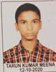
2. | Arpita Khare | 79% | 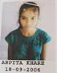
3. | Kunal Tekam | 72% | 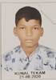

Student- Teacher Ratio = 160:6 =26:1
Average Workload of Teachers = 26
Total teaching days:-
From LKG to IV – 212 Days till 10th March
From V to X – 234 Days till 31st March
School Timing
TIMING
 | FROM | TO
 | 8:00 AM | 2:00 pm

Details of teachers and staff working in the school
S.NO. | 2022-23 | 2021-2022 | 2020-21
Principal | 01 | 01 | 01
Teachers | 09 | 04 | 06
Accountant | 01 | 01 | 01
Lab Assistant | - | - | -
Peon | 02 | 02 | 02
Total | 13 | 08 | 10

Academic Activities:-

National Festivals (Independence Day, Republic Day)
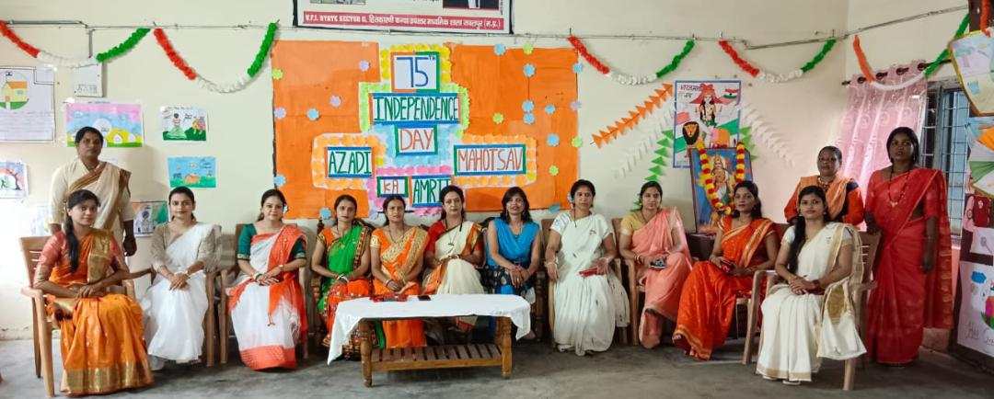
On the occasion of Independence Day and Republic Day by the School Principal hoists the National Flag. We celebrated National Festival of India 15th August as Independence Day and 26th Jan as Republic day with patriotism and great zeal. Cultural activities were performed by the students with very enthusiasm.
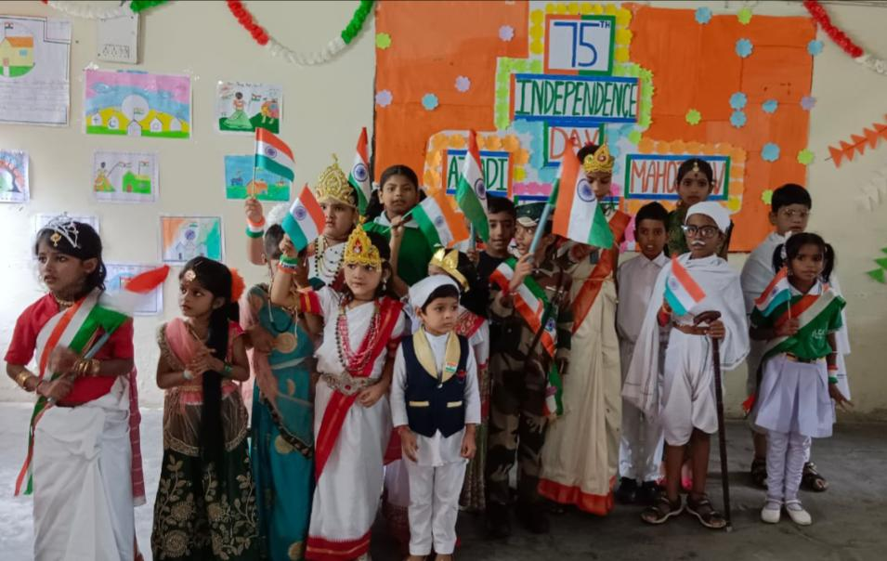
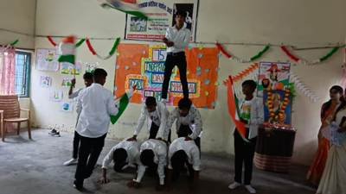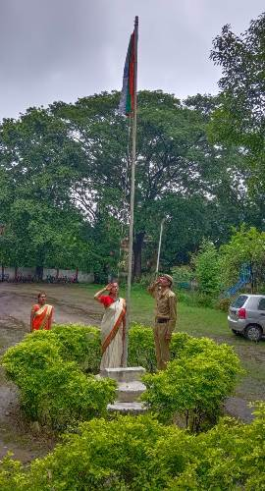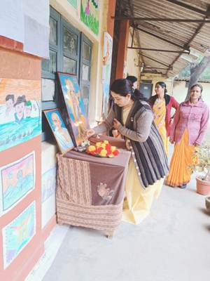

Janmashtami Celebration:-
Krishna Janmashtami was celebrated with great pomp and festivity by the tiny-tots of the pre-primary section at our school.The cute little ones were dressed as Radha and Krishna. The primary kids added a traditional touch to the entire
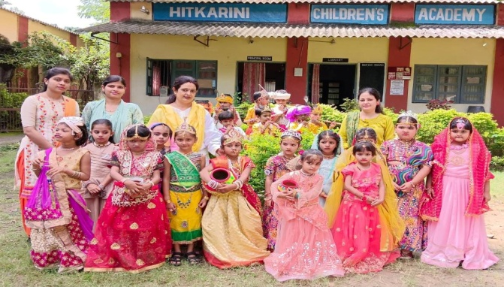
elebrations when they danced to the beat of Janmashtami songs, filling the air with joy and festive spirit. The Acting Principal Mrs.Divya Nayak and cultural In – Charge Miss Shivani Dagoor, Miss Abhilasha Rajpoot with all staff encouraged the students and enjoyed the function thoroughly.
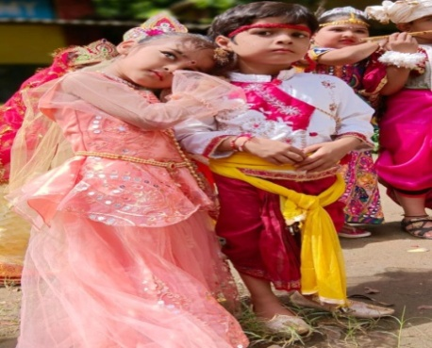
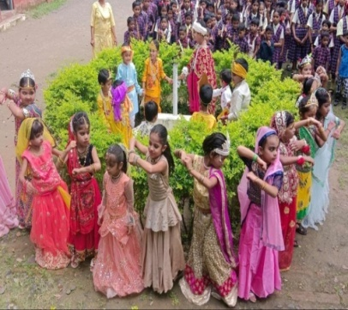
Rakshabandhan Celebration:-
Rakshabandhan is one of the most endearing ways to celebrate bond between brothers and sisters. To strengthen this bond ‘Rakhi Making competition’ , 'Mehendi competition' and 'Card making Competition' was done in school. Students of school made colorful eye catching rachis as they participated in the ‘Rakhi Making Competition’.
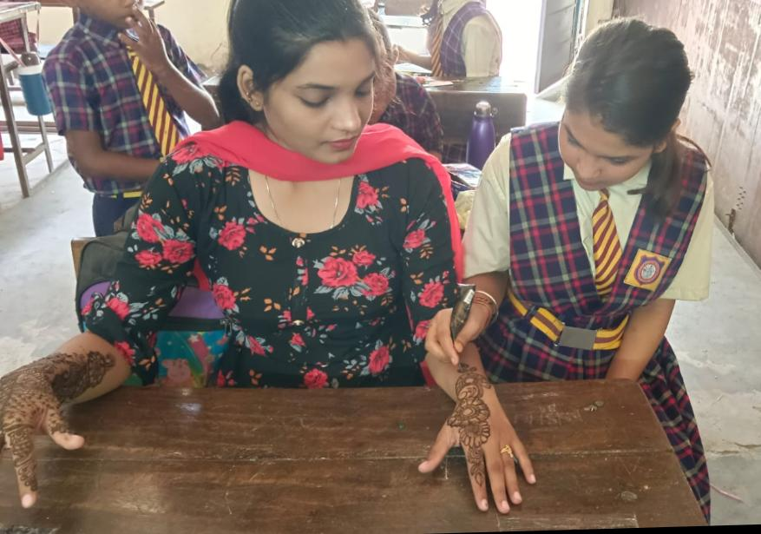
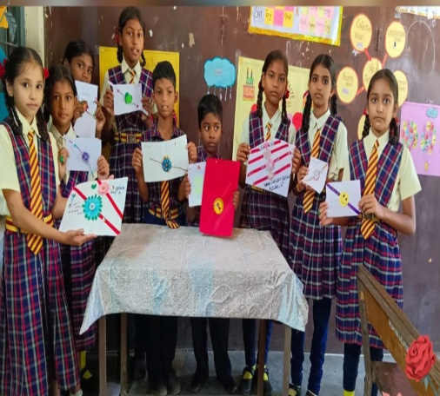
We wish that with help of these activities we can teach our children our Indian Culture.
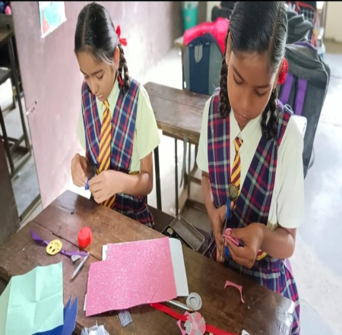
Green Day Celebration:-
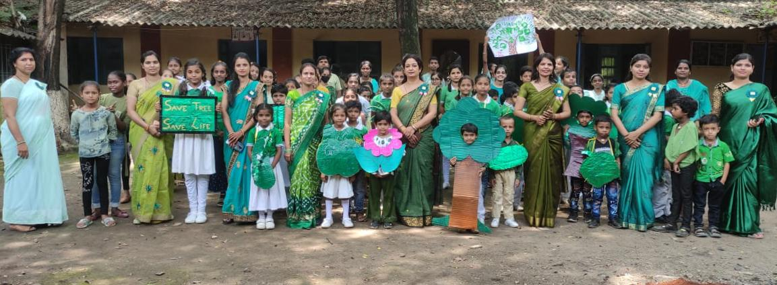
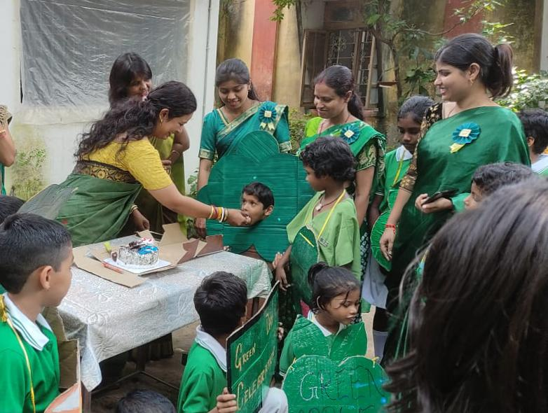
The little Champs of HCA VFJ School celebrated Green Day in the lap of Mother Nature. The main objective of the celebration was to create awareness about saving the environment and to acknowledge the contribution of Mother Nature.

Teachers’ Day Celebration:-
Teachers' Day in India is celebrated every year on September 5 to mark the birth anniversary of Dr. Sarvepalli Radhakrishnan. He was a former President of India, scholar, philosopher and Bharat Ratna recipient.
Teachers’ Day is a special day for the appreciation of teachers and may include celebrations to honor them for their special contributions in a particular field area, or the community in general.
“Teachers are the backbone of any country, the pillar upon which all aspirations are converted into realities.”- A P J ABDUL KALAM.
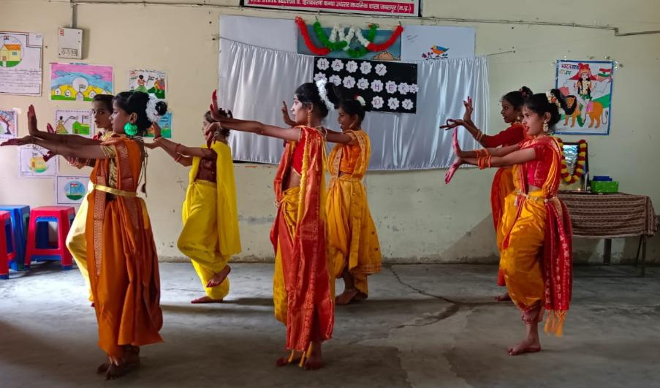
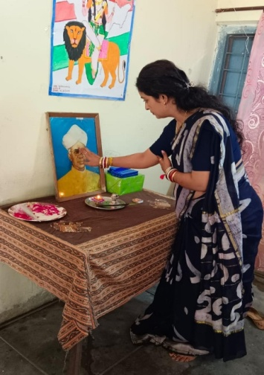
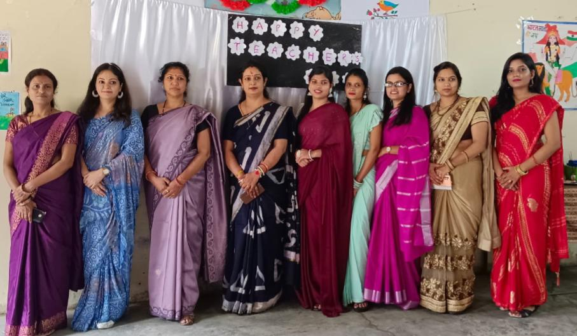
The programmed was hosted, organized, and carried out by the students of classes X..

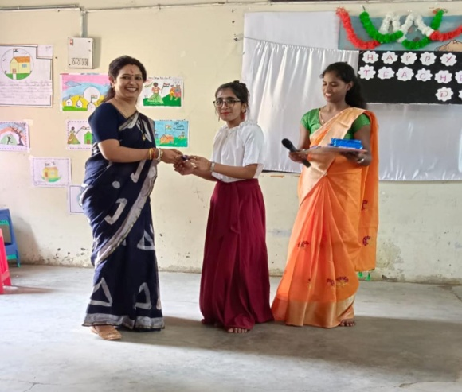
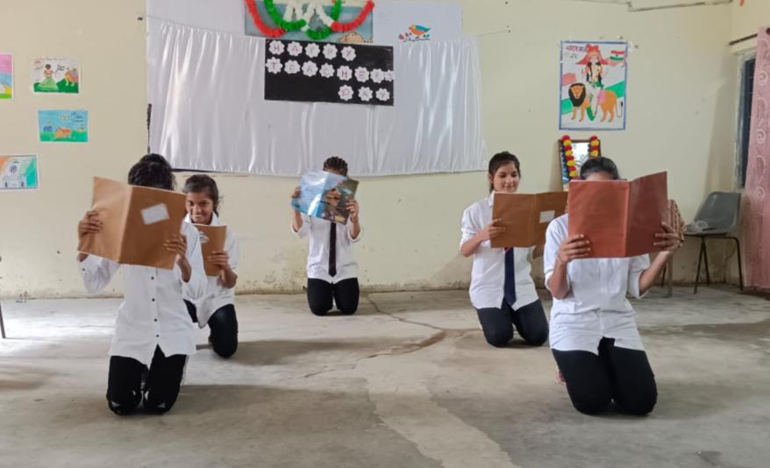
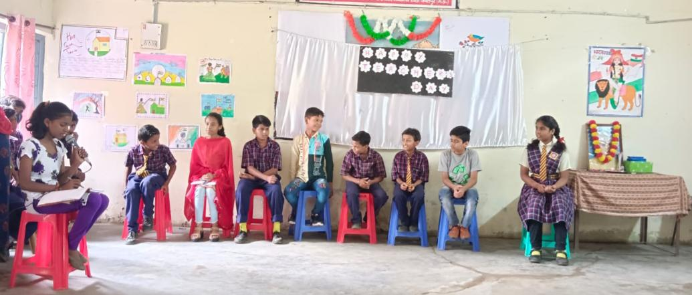
International Literacy Day:-
”Once you learn to read you will be forever free”
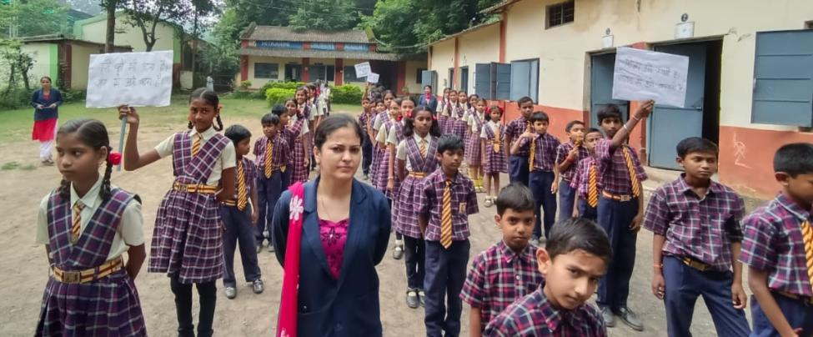
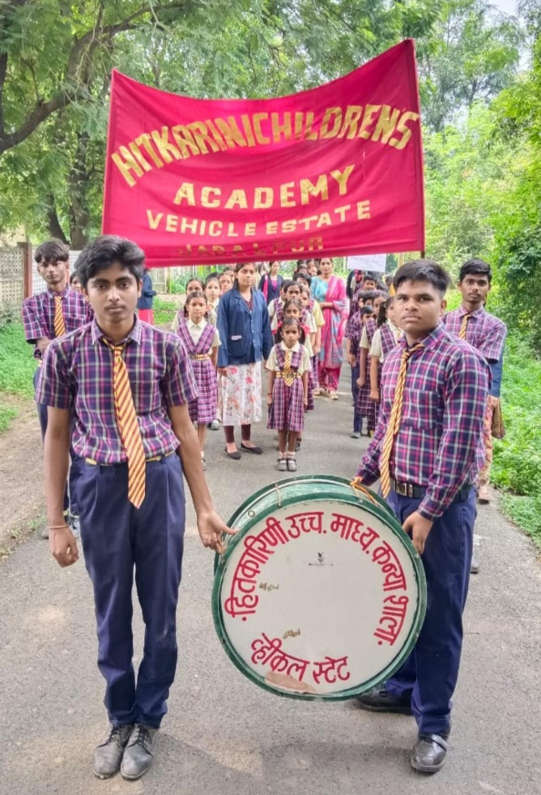
8th September 2022 is a International Literacy Day .On this occasion an awareness rally were organized by our school. All staff and students of HCA, VFJ participated in that rally. The rally started from our school campus and went to the public place.

Diwali Celebration:-
Diwali is the festival of lights which is celebrated in various regions across India. The name ‘Deepavali’ literally means an ‘array of lights’. To make the students understand the importance of Diwali, HCA,VFJ had a celebration in school . Teachers explained the importance of Diwali, the festival spiritually signifies the victory of light over darkness, knowledge over ignorance, good over evil, and hope over despair. Children decorated diyas with colors and glitter and also decorate the rangoli in the school corridor and make the diwali greetings cards .
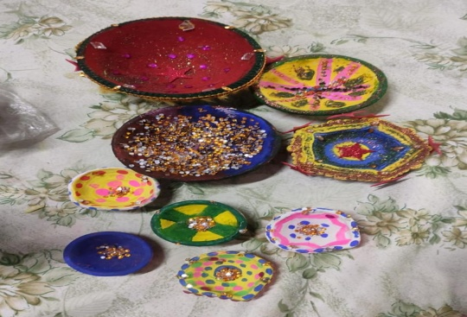
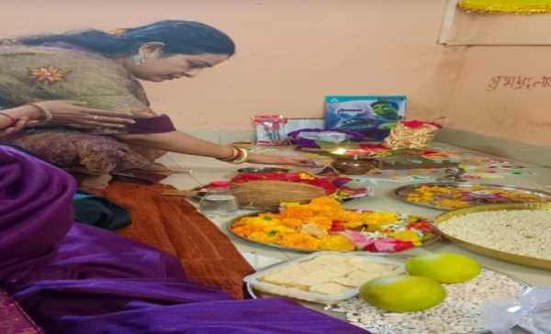
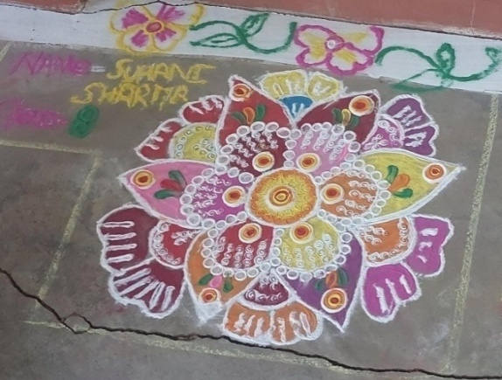
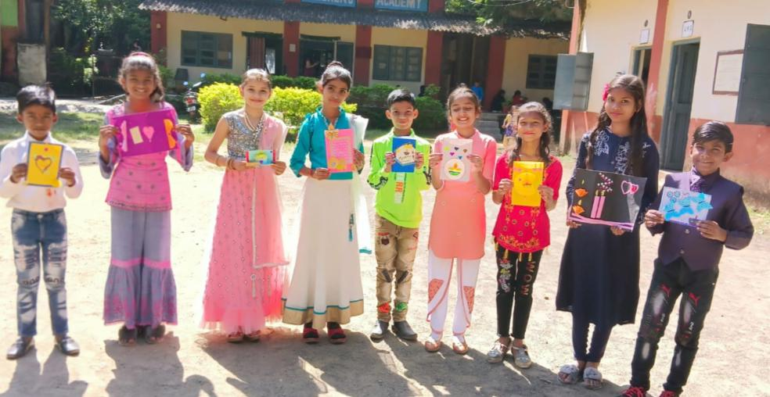
Inter Hitkarini Dance Competition:-
The cultural program organized by our Parenting body vidhya Parishad , Hitkarini Sabha on 21 November 2022 with great zeal and enthusiasm. All the Hitkarini`s schools and colleges participated in this program.
Our school “ HITKARINI CHILDREN’S ACADEMY V.F.J” presented group dance *Maharashtra folk dance* titled as “ Lavani” which is a combination of traditional song and dance. It is particularly performed to the beats of Dholki, a percussion instrument. Lavani is noted for its powerful rhythm and solo semi classical dance performed by 10th class student Miss Diya katheriya
Dance is the conversation of the body with the soul. As an art form, it has been an integral part of Indian culture and heritage since ancient times. The diverse culture of India exquisitely treasures a wide variety of folk and tribal dance forms that vary in style of different regions across the country. In its true sense, dance is not just a good form of exercise, but is also a great source for boosting creativity, imagination, confidence and focus of young .
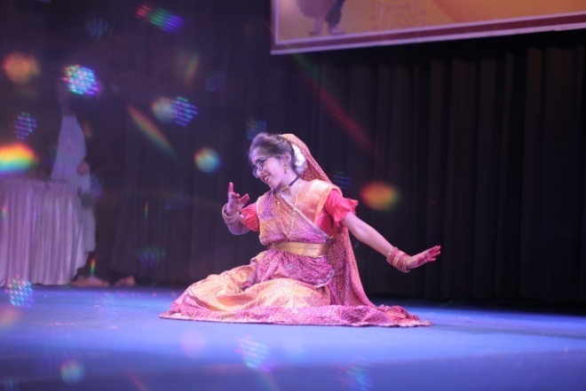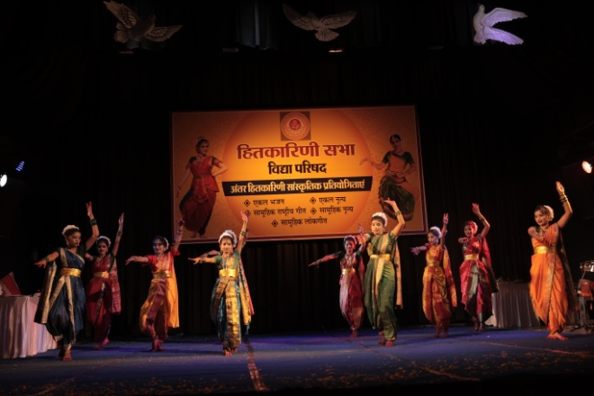

Inter Hitkarini Sports Competition:-
For fulfilling this mission our Parenting body vidhya Parishad , Hitkarini Sabha has taken an initiative to engage students of different ages in different sports activities through a consolidated sporting event called “ INTER SCHOOL SPORTS COMPETITION “ This two-four days sports programmed had involved different types of sports like kho-kho, kabaddi, Races 200-400,relay races, aerobics, P.T., shot-put, javelin throw, discus throw.
Our school HITKARINI CHILDREN’S ACADEMY V.F.J students participated in different sports as mentioned above and secured positions in following sports :-
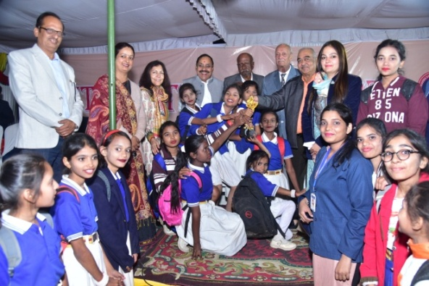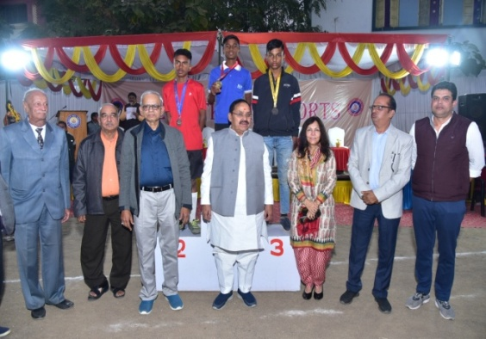
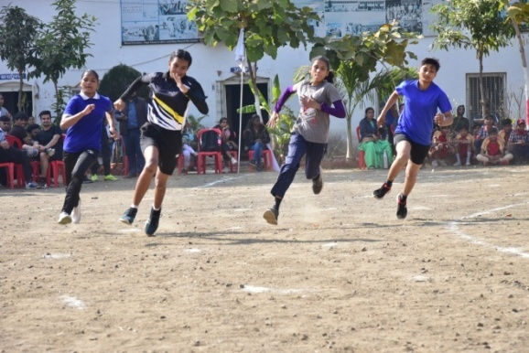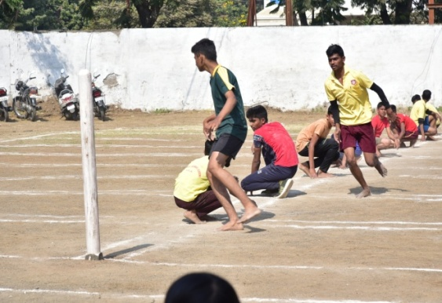
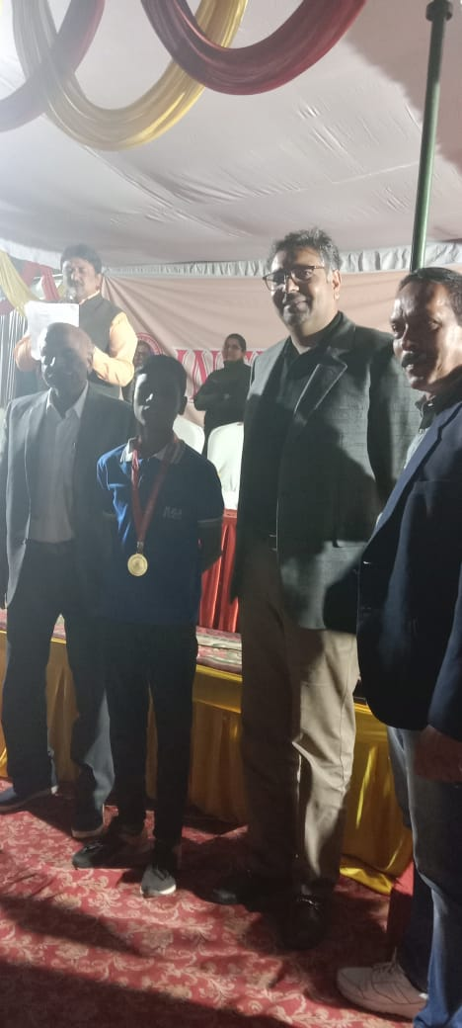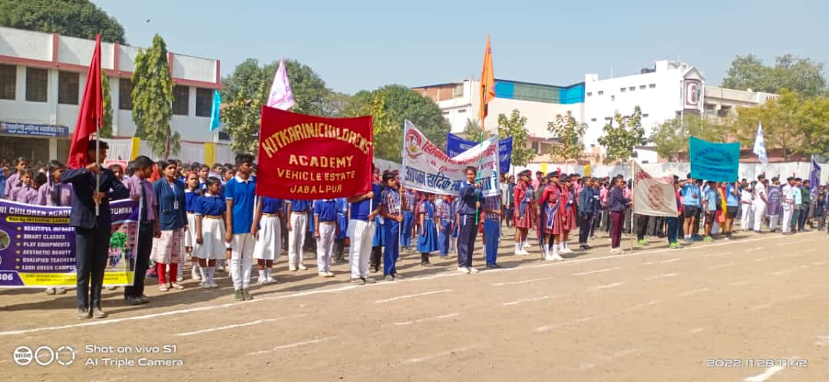
1.Gold medal - Mayank parte VII class[Race]
2.Silver medal – RosemitaTopno IX class[Race]
3.Bronze medal – YogeshRajak X class[shot put]
4.Bronze medal - Aerobics students (Middle)

Sports and Cultural Presentation in VFJ, Jabalpur organized by VFJ, Jabalpur:-
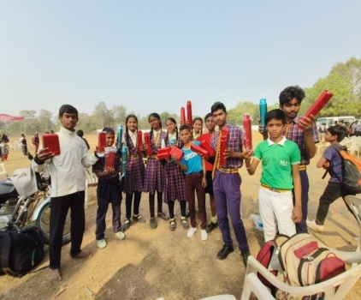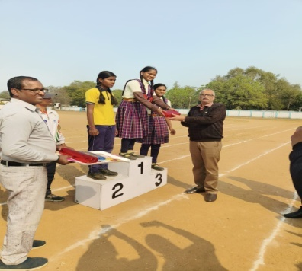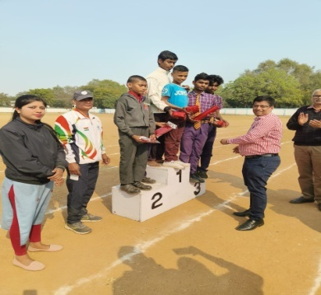
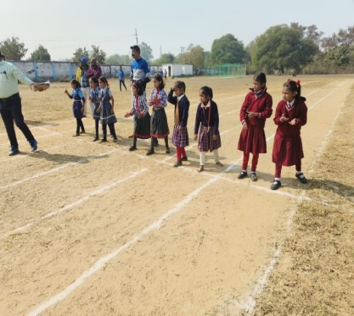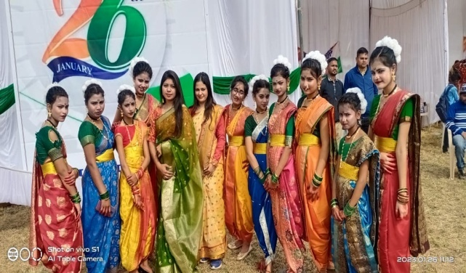
Basantpanchmi:-
Saraswati, the deity of knowledge, wisdom, learning, music and art symbolizes creative energy. Worship of ‘Goddess of Learning’ holds special meaning in schools and colleges. On the fifth day of Magha, also known as Vasant Panchami, Saraswati puja is celebrated by students as well as teachers from all walks of life in India.
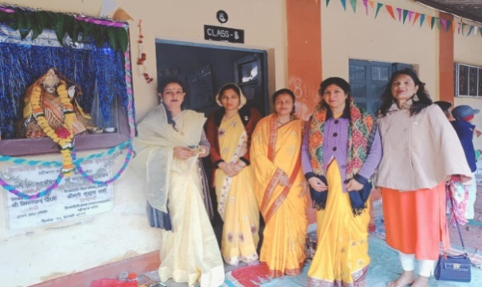
HCA VFJ SCHOOL organized Saraswati Puja with Hawan Ceremony in school compound. All the teachers wearing yellow and white coloured dresses offered their prayers to MaaSaraswati and worshipped for the progress of all the students and school as well. The pooja ended with the ‘ Arti’ and the distribution of ‘Prasad’ to the staff and students
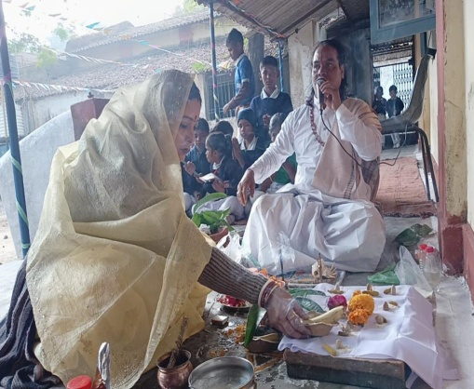
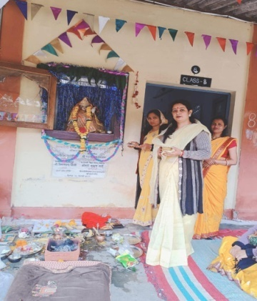

Clebration of children`s day on 14 Nov.2022:-
Children’s Day is celebrated on November 14th all over India. This signifies the birthday anniversary of Jawaharlal Nehru, as he was fond of children, and was lovingly called Chacha Nehru by kids across the country.
On this occasion Acting Principal Mrs.Divya Nayak distributed the Pens to the dear children’s.
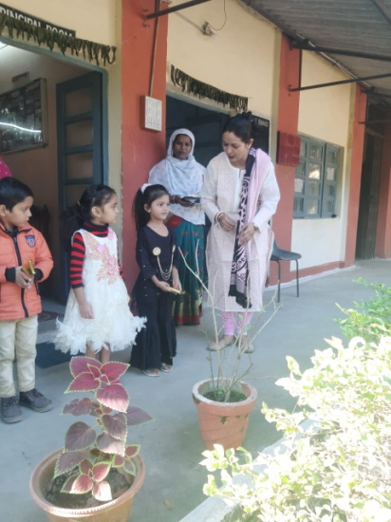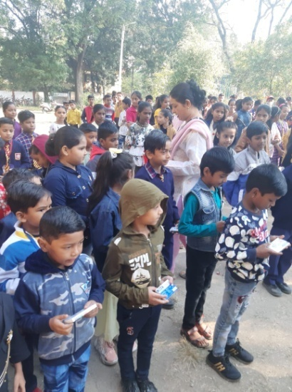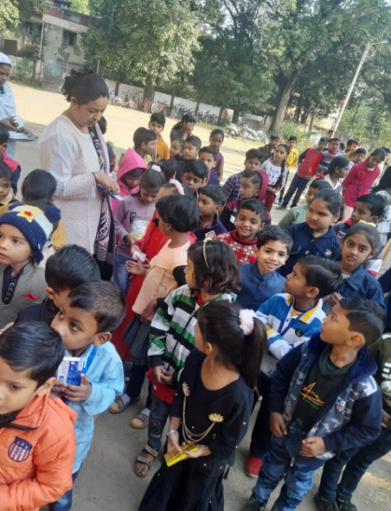
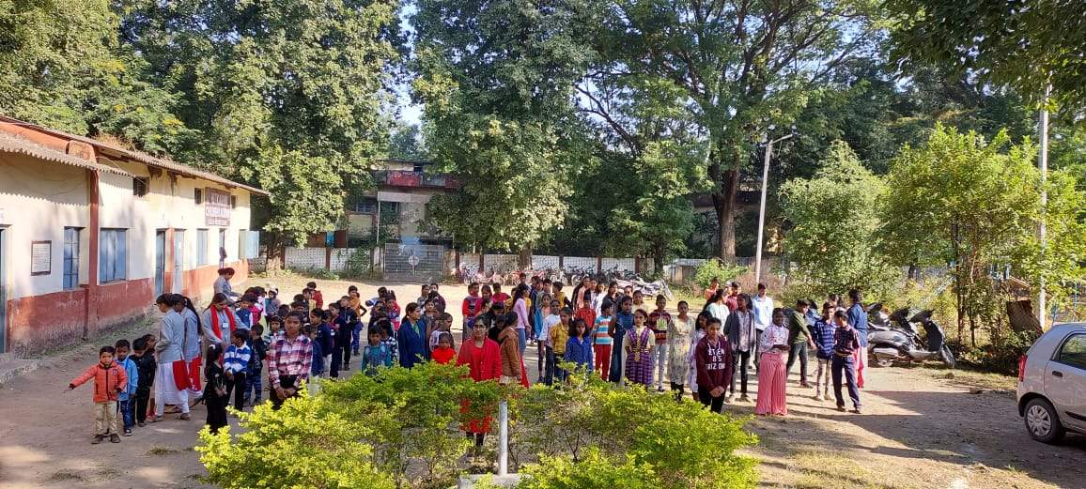
Computer Lab
Computer Lab in our school is systematic and well equipped. There are five computers in computer lab, two computers and one printer in the office. Students provided teaching and practicing of computer by teachers.

Number Of Book In Library - 504 Books
Parents Teachers Meeting - Quarterly Examination, Half-yearly Examination, and Pre Board Examination (2022-23).
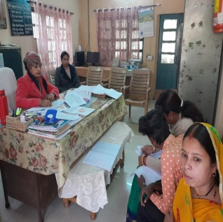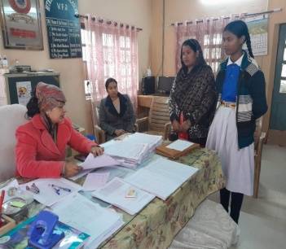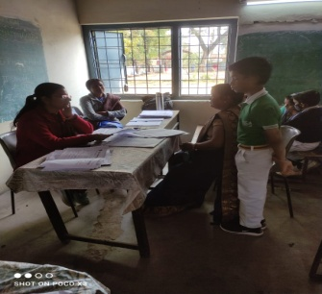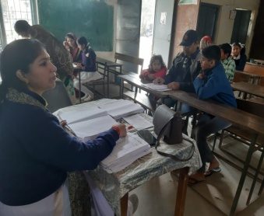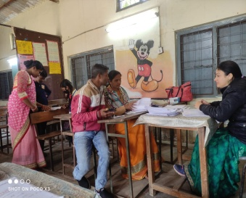

Scholarship Description session (22-23):-
Name of the Institution | Number of PBF students of the institution |  | Assistance to poor / meritorious students from other social, religious and other institutions for students studying in the institution
 | No. | Amount | No. | Amount
Hitkarini Children`s Academy, VFJ,Jabalpur |  |  | - | -
Proposed Plan for New session
We all as a staff of Hitkarini Children`s Academy , VFJ proposed plan for coming session want to give a good education to students, give a proper and moral values ​​and making their future bright with the some maintained infrastructure of the school building.
This will reflect the good and optimistic results for us.

Acting Principal Name - Smt. Divya Nayak
Designation - Acting Principal
Qualification - M.E. (Digital Communication)
B.E. (Electronics and Communication)
Mob.No. – 09584627189

